Mountain of Fire and Miracles Ministries
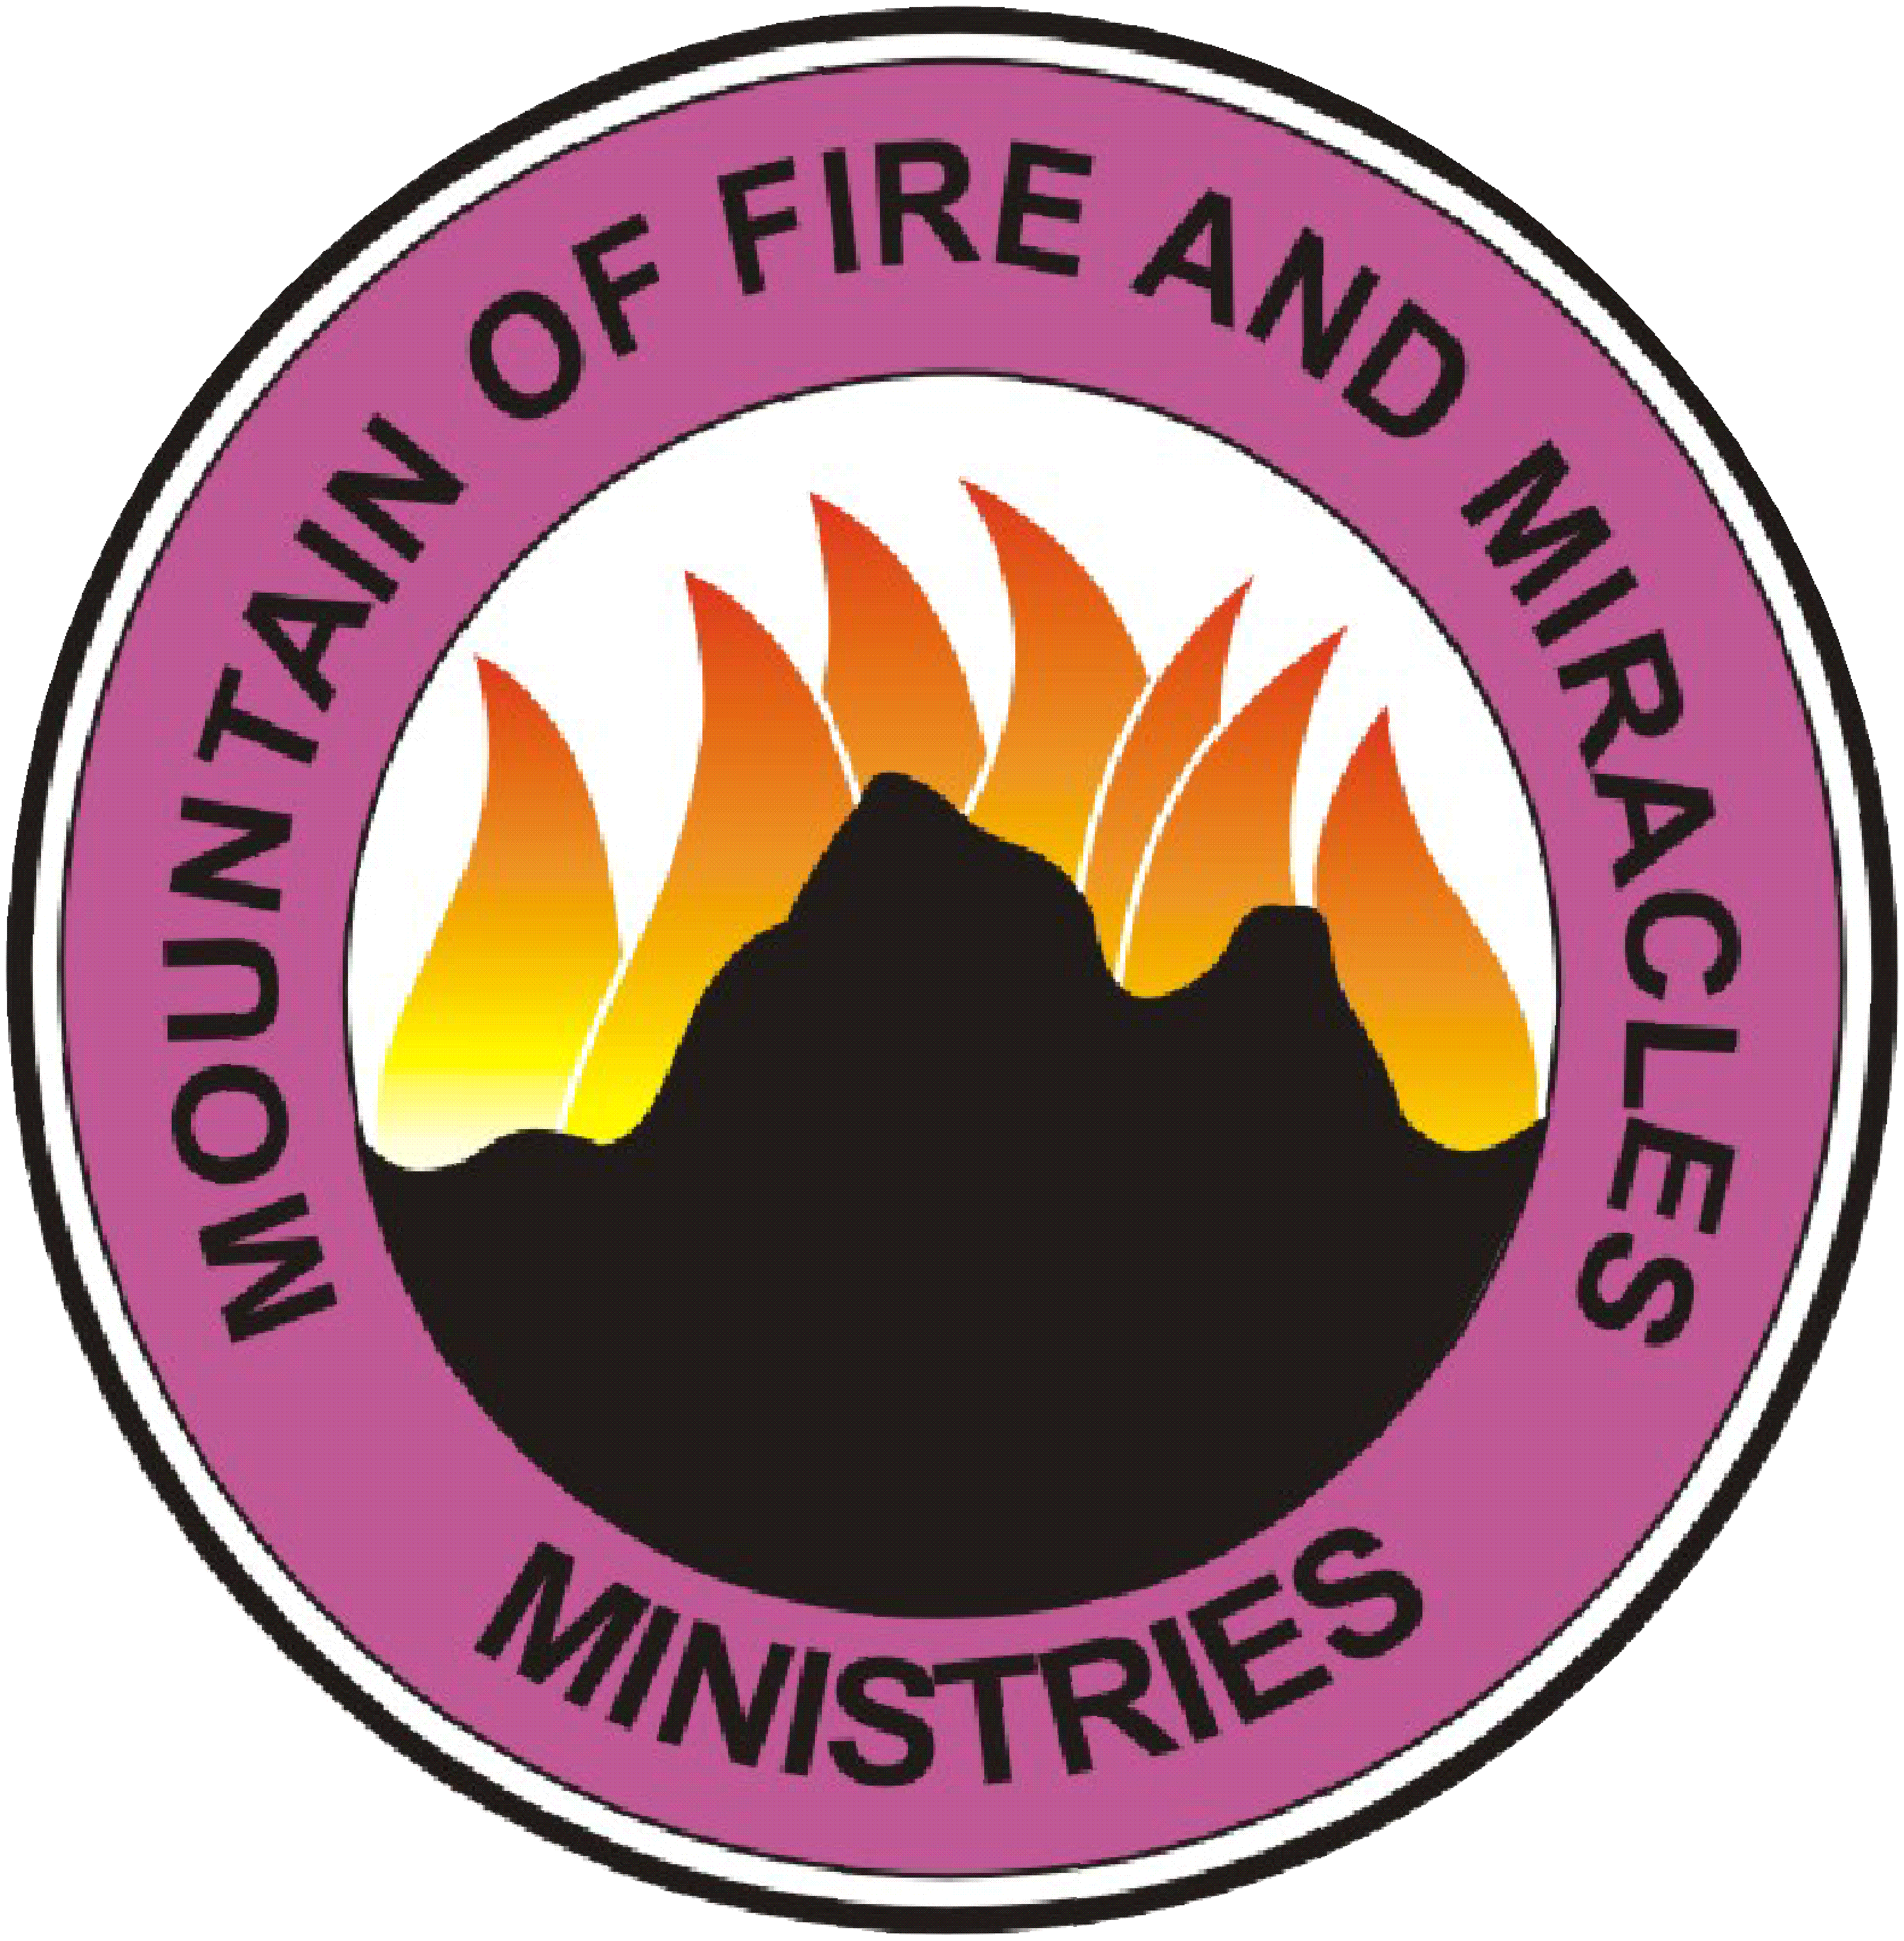
Revival Chapel
16211 Clay Rd. Ste. 114 Houston TX 77084

DELIVARANCE PROGRAM PACKET
ATTESTATION FORM
To Whom It May Concern

I, ___________________________________________________ (full name) chose to attend deliverance, prayer and fasting program at Mountain of Fire & Miracles Ministries. In case of any eventuality or accidentally hitting my head on the wall or any occurrence of accident during the process of deliverance, I attest that I am solely responsible for any accident that I may incur. By signing this form, The Mountain of fire and Miracles Ministries and its ministers are therefore absolved from any legal action.
I am also fully aware that the success of my deliverance is based on:
- My Repentance, Confessing and Accepting Jesus Christ as my personal Lord and Savior;
- Adhering to every instruction given during the Deliverance Program;
- Beginning a consistent Christian life with Jesus in a Bible believing and Spirit-filled church; not going back to that which I have forsaken.

My signing this form show that I am fully aware of the deliverance process/protocol

Deliverance Candidate Date

Coordinating Pastor Date

Mountain of Fire and Miracles Ministries
(Revival Chapel)
Houston
Regional Headquarters Central Zone
DELIVERANCE PROGRAM PACKET
16211 Clay Rd Ste. 114 Houston, TX 77084

This packet contains key information in preparation for the deliverance programs

DRESS CODE

WOMEN:
Please remove all every artificial attachment because these things do prevent or hinder deliverance. Including hair pieces, weaves, fake nails, nail polish, nose, belly, tongue rings etc. Exodus 33:5-6, Isaiah 3:16-26,Ex 21:6, Det 15:17.
(You will be required to remove them before you are allowed into the program)
• Remove all jewelry including wedding rings. Only watches are allowed and cannot carry demonic images.
• Please wear skirts or dresses. They should be long and at least midway between your ankle and knee to cover you properly if you fall. Avoid tight fitted outfits and cleavage revealing top. Sleeveless, armpit revealing tops are not recommended.
• Dress and shoes prints should not have demonic images like snakes, dragons etc.
• When packing please bring scarves or hats to cover your head. I Cor 11:10

MEN:
Only watches are allowed.
All hairdos like dreadlock, Mohawk will not be allowed into the program, and you will be required to cut it before you join the program.

FASTING
Those attending the deliverance service will be placed on a 3 - day dry fast
Your last meal should be consumed by midnight Thursday until after the Deliverance Program Saturday or Sunday ( dependent on deliverance schedule of events)
Please notify if there is a medical reason that may require an adjustment to your fast.

ALSO INCLUDED IN THIS PACKET IS THE DELIVERANCE QUESTIONARE THAT WOULD NEED TO BE COMPLETED AND BRING WITH YOU FOR YOUR, ONE ON ONE COUNSELING SERVICE.

Other important information:
Although there is no cost to attend the deliverance program, you are encouraged to bring money for books and resources that will be recommended to maintain your deliverance.

We do not have babysitting services therefore children are not allowed on deliverance grounds. Please make arrangements for their care prior to starting the program.

Deliverance Questionnaire: Please bring the included deliverance questionnaire with you for your Counseling session completed.
If you have any additional questions or concerned be sure to inquire.

Thank you,
MFM Revival Chapel

DELIVERANCE QUESTIONAIRE

CONFIDENTIAL
MFM Revival Chapel Houston Deliverance Questionnaire
The purpose of this questionnaire is to obtain information that will be helpful to us in determining the prospect of demonization and the inroads or open doors through which the demonic powers have gained entrance into your life, for the objective of deliverance, spiritual warfare, and counseling. The information you provide as well as all matters discussed during counseling are completely confidential, and this sheet is only available to the ministry counselor or pastor. Responses to all questions are entirely optional. However, the more information you provide the more and more easily we will be able to help you. Complete honesty and forthrightness with yourself, God, and your counselor is essential to effective counseling and deliverance.
CONTACT I PERSONAL INFO
Date of initial visit _ _/ ___ _ __
First Name __________Last Name __________Age_ __
Address--------------------------------
Phone() __ __ __ _ _ _Email Address _________
Referred By_ ________ __ _____________________________________
Year saved_ _ Age when saved _ _ Year Spirit-Baptized _ _ Age when Spirit-Baptized_____
1. PERSONAL HlSTORY:
Church affiliation - present ______________
past __________________________ _ __
Marital status: married _ _separated _ _ divorced _ _single_ _______
widowed_ _ _ how many children__
If married before, how many times______________________________
With whom are you now living________________________________
Do you have regular devotions in the bible_ _____________________
Do you find prayer difficult __________________________
Do you listen to a lot of music ___ what type do you enjoy most _______ _
How many hours of tv do you watch per week_ _________
Are you adopted_ ________________
Have you ever attended a new age seminar, or participated in a seance_ ___________________________________
What spiritual experiences have you had that would be considered out of the ordinary________________________________________________
To your knowledge, have any of your parents, grandparents, or great-grandparents ever been involved in any occultic, cultic or non-Christian religious practices__________
How many children in childhood family __________________
Where are you in family line of siblings: I st ___2nd__ 3rd___ 4th__ 5th
Relationship to father in childhood: good __ bad_ indifferent_
Relationship to mother in childhood: good_ _bad_ indifferent_
Relationship to siblings: good_ _bad__ indifferent_
Has there been a significant change in any of these at present____________
Which of the following applied to you during your childhood?
Night terrors ___bed wetting __ sleep walking__ Incest _nail biting __unhappy__ childhood __ Stammering _ _ excessive fear _ _ problems learning ___Loneliness __sexual encounters __mole station__ Broken home __removed from home___ inappropriate touch _
Personal sin issues (list all that you are struggling with now?)
1) _______ 4) ________
2) _______ 5) ________
3) _______ 6) ________
Emotional problems (Check all that apply that are of a persistent nature)
__ Depression__ Suicidal Ideation/acts__ MPD/DID _Schizophrenia _
-Anger-toward whom?__________ _
Rage -toward whom? ____________
Hate -toward whom?_______________
Unforgiveness -toward whom?______
CONFLICTS WITH PEOPLE
Do you have any persistent conflicts in your family relationships?_ Yes_ No
If yes, with whom? _________ _
Do you have any persistent conflicts with another person/persons besides your family?________ Yes _ No__ If yes, explain: _______________
EXTREME OR ABNORMAL CONDITIONS (Check all that apply)
___Fears/Phobias_________________
__Resentment/Discontentment with:_______________
__Self-pity _ Bitterness _ Self_ Envy_ Racism _ Spouse _ Pride _ Anti-Semitism _Family__ Jealousy __Unbelief__ Current Circumstances__ Unpredictability__ Doubt__ Self-punishment__ Mental/Emotional (describe) ____________Physical (describe) ________ ~ Others:_____________
TRAUMA TIC EXPERIENCES (Check all that apply)
__Childhood _ Adolescence _ Adulthood _Abortion _Murder_ Rape _Incest_ Molestation_ Sexual abuse_ Emotional abuse_ Controlled by another_ Sudden death of a loved one __Physical attack_ Divorce of parents. Other ____________________
Divorce runs in your family? _ Yes_ No
Explain checked answers (what sort of trauma, who was involved): ________________________________________________________
DESTRUCTIVE HABITS (Check all that apply)
_ Lying _Blasphemy _Abuse _ Gossip _ Criticism _ Temper/ Anger Fits
_Drugs _ Drinking_ Gluttony_ Anorexia_ Bulimia_ Tobacco use _ Sniffing
_Stealing_ Vandalism_ Cutting oneself_ Pulling hair out _
Others:
IMMORAL ACTIVITIES (Check all that you have participated in)
_Homosexuality_ Lesbianism_ Bi-sexuality_ Adultery_ Fornication (unwed sex)_Masturbation_ Incest_ Sodomy_ Rape _Pornography/Fantasy Lust
_Bestiality _Lust_ Voyeurism_ Exhibitionism_ Orgies/Mate Swapping _ Oral sex __ Others (list:) __________________________ _
Describe:
__ I have had desires for these sorts of things listed above but have not acted upon them. List which one(s):

__I possess pictures/videos/books of the above acts being performed. List which one(s):
SOUL-TIES
A soul-tie is any improper, unbiblical, or ungodly relationship involving unnatural, excessive devotion, dedication, or affection. A soul-tie can occur between friends, relatives, spiritual cohorts, intimates, student-teacher, protege-mentors, and other types of relationships. Generally, some form and degree of seduction and predomination by one party over the other is involved in the relationship. Improper, unbiblical, and demonically inspired covenants, pledges, and oaths are sometimes involved.
__Emotional -With whom?________________________
__Sexual- With whom?__________________________
_ Psychological-With whom? ______________________
_ Spiritual -With whom? __________________________
TATTOOS, BODY PIERCINGS, AND OTHER BODILY DEFILEMENTS
Please list and describe any tattoos, body piercings, or other defilements of your body:_____________________________________________________
DRUG AND ALCOHOL HABITUATION AND ABUSE (Check any of them you have used)
_Marijuana_ Hashish_ Peyote_ Crack_ Cocaine_ Heroin_ LSD_ Methedrine _Nembutal _ THC _ STP _ Speed _ Amphetamines _ Sleeping pills_ Pain killers_ Anti-depressants_ Antipsychotics _Ecstasy_ Other drugs, narcotics:
_ Habitual or frequent excessive drinking, recreational drinking, drunkenness, alcoholism
Have you ever been involved in the sale or distribution of illegal drugs? _ Yes _ No__
Are you still on them ___ List _____________________ _
CONDEMNATION - GUILT
__ Regarding past sins in general_ Fear of committing sins_ Fear of not being forgiven_ Unforgiveness of oneself_ Unpardonable Sin _ Abortion
__Divorce / remarriage _ Other
Explain checked answers here:___________________________________________________________________________________________________________________________________________________________________________________
GENERATIONAL INIQUITY/CURSES (IN IQUITY OF THE FOREFATHERS)
Some demons gain entrance and have a legal right to operate through generational iniquity (perversion), i.e., "the iniquity of the fathers." List below known iniquities or habitual sins of your ancestors you have also experienced?
Mother's sin issues:___________________________________________
-Father's sin issues:___________________________________________
Grandpa (Mother's side): _________ Grandma (Mother's side): _______ _
Grandpa (Father's side):_________________________________________
Grandma (Father's side):_________________________________________
Great-grandparents: ___________________________________________
Siblings: __________________________________________________
Uncles, aunts, relatives: _____________________________________
other notes and comments __________________________________
Which of the following have you struggled with in the past or are you struggling with presently?
_daydreaming_ lustful thoughts _thoughts of inferiority_ thoughts of inadequacy_ worry_ doubts_ fantasy _obsessive thoughts _insecurity _
blasphemous thoughts__ compulsive thoughts _dizziness _headaches

Which of the following emotions have you had difficulty controlling or are you presently having difficulty controlling?
frustration __fear of death __anger __fear of losing your mind__ loneliness __fear of committing suicide _anxiety_ fear of hurting loved ones__ worthlessness _depression__ hatred__ bitterness
Moral climate during the first 18 years of your life.
How would you rate the moral atmosphere in which you were raised: __________________________________________________________________________________________________________________________
Medical history
Ever had operations, if so, for what reason and your age at that time
___________________________________________________________
Hospitalization for emotional illness yes
_ no ___ why _______________ _Diagnosis, date, discharge status
Form of treatment____________________________ _
Currently under care of doctor _ _ __ or psychiatrist _ _____ _ _ ______ _ _
On drug therapy ___ date_______________
discharged ______________ _
Subject to depression___ frequency _______________ _
Duration_____ diagnosed as ____ ___ _ PMS?_______ _
3 OCCULT ACTIVITY -PAST OR PRESENT
Ever sought or been subjected to any form of occult "healing" through an occult healer, such as:_ Shaman/Witchdoctor _Witch/Warlock_ Spiritualist healer _ Voodoo Practitioner_Psychic healer_Metaphysical healer _Christian Scientist _Acupuncture
Ever sought or been subject to any form of occult prognostication, such as:
_Pendulum_ Divining (e.g. water witching rods, wedding ring, needle and thread, et al.)?
Ever used or worn: _amulet _ talisman _ rabbit's foot _ "magic" or "good luck" charms?
Ever been involved in Halloween trick or treating, haunted houses, or other "fright" activities? __Yes__ No
Ever participated in any form of martial arts?_ No_ Yes ________ form:
Ever practiced or been involved with: __Spells/hexes___ Meditation
__Telepathy ___E.S.P. __Mental suggestion
Ever studied, read about, played, performed, or participated in:
_Wicca _Witchcraft_ White/Black magic _ Spirit Guide _ Satan or Angel worship__ Seance_ Vampirism _Blood drinking_ Blood spilling_ Medium channeling__ Yoga _ Hypnosis __Horoscopes/Astrology_ Ouija Board _ Tea leaf reading__ TM__ Palm reading _ Tarot card reading __Levitation_ Automatic (spirit) writing__ Dungeons & Dragons _ Occult video games__ Harry Potter__ occult or new age books
Ever sought or used a: _ psychic_ medium _spiritist _witch/witchdoctor _ crystal ball gazer.
Ever had a/an: __imaginary playmate __spirit-visitor __visitation of deceased ancestors
YES/ NO
___ Have you ever visited a fortuneteller who told your fortune using cards, tea leaves, palm readings, and so on?
____ Do you read or follow a horoscope?
____ Has anyone ever hypnotized you? Who?____ ___ _
__ __ Have you ever practiced yoga or done exercises related to yoga, Pilates …etc?
____ Have you ever had a life or reincarnation reading?
____ Have you consulted a Ouija board, planchette, cards, tea leaves, crystal ball, etc?
____ Have you played with the so-called 'games' of occult nature? (ESP, Telepath y, Kabala, Dungeons and Dragons, 8 ball, etc.)
____ Have you ever consulted a medium?
_ __ Have you ever sought healing through magic or through a Spiritualist, Christian Scientist, or anyone who practices 'spirit healing' psychic healing, hypnosis, metaphysical healing, use of the pendulum or trance for diagnosis, or any other occult means?
____ Have you been to a chiropractor who treats through the use of ying and yang, the universal life forces in the spine?
____Have you ever sought to locate missing objects or persons by consulting someone who has psychic, clairvoyant, second sight, or psychometric powers?
____ Have you ever practiced table-lifting, levitation, or automatic writing?
____Have you ever been given or worn an amulet, talisman or charm for luck or protection?
____ Have you, or has anyone for you, practiced water witching using a twig or pendulum?
____ Do you read or possess occult or spiritualist literature, e.g., books on astrology, interpretation of dreams, metaphysics, religious cults, self-realization, fortune telling, magic ESP, clairvoyance, psychic phenomena?
____ Do you often have nightmares or frightening dreams? Have you ever been "guided" by a
dream?
____Have you experimented with or practiced ESP or telepathy? Have you ever "thought" at a
person or tried to make them call or write you by your thoughts?
____ Have you ever practiced any form of magic charming or ri tual?
____ Do you possess any occult or pagan religious objects, relics, or artifacts which may have
been used in pagan temples and religious rites, or in the practice of sorcery, magic, divination, or
spiritualism?
____ Have you ever had your handwriting analyzed, practiced mental suggestion, cast a magic
spell, or sought psychic experience?
____ Have you ever belonged to the Masons, DeMolay, Job's Daughters, Eastern Star?
_ __ Have you been involved in a lodge or organization requiring rituals for membership?
____ Do you see auras?
___ Do you ever 'fee l' an evil presence?
____Have you ever been visited by a demon or an evil spirit?
____ Have you ever gone in any temple or building that was not Christian (Buddhist temple, Mormon temple, etc.)?
____ Have you ever been involved in any group involved in rebellion or terrorism?
___Have you had negative things or curses spoken over you?
___Does your name have any particular significance as to family tradition or cultural/national
heritage?
DEMONIC, RELIGIOUS, OCCULT PARAPHERNALIA (Check all in your home or in/at/on any property you own)
__Tarot Cards _Crystal _Energy Balls _amulets _ "Good luck" charms/jewelry_Occult jewelry _Heavy Metal or Rap music _ occult games __Religious Medallions or statues_Demonic, occult, or pagan art objects, relics, artifacts, or images (e.g., Buddhas, Sun gods, Egyptian
gods)
_Mormon, Jehovah Witness, Catholic, or Christian Science paraphernalia _
Free Masonry paraphernalia__Relics, arti facts, or other paraphernalia that may have been used in pagan temples, religious rites, or in the practice of sorcery, magic, divination, or spiritualism._Indian religious paraphernalia, art objects, relics, artifacts, or images (e.g., dream catchers, peace
pipe)__Graven images of God (pictures of Jesus, Jesus on a cross (crucifix), etc.)__Demonic books, comics, or videos on: _ Vampires/werewolves _the weird _Horror__ Occult, spiritualism, or new age books or other publications on:__ Astrology _Horoscopes__Dream interpretation _Fortune telling__Metaphysics _Religious cults _Eastern Religious _Self-realization
_E.S.P. _Clairvoyance _Mind control_ Psychic phenomena__Meditation _
New Age Topics_ Black/White magic_ Altered Consciousness__UFOs _Paranormal __Numerology__Halloween, St. Patrick's Day, Easter Bunny paraphernalia Other:_________________________________________
Did your parents wish you were of the opposite sex?
____ Have you read literature by Jean Dixon?
____ Have you read literature by Edgar Cayce?
____ Have you been involved in satan worship?
____ Have you ever practiced Astral projection?
____Have you been involved in white magic: doing good things through the control of psychic and supernatural power?
____ Have you been involved in black magic: psychic control through curses, use of the black arts, or any demon power for the purpose of harm?
___ Have you ever been involved in or attended any of the Eastern religions?
__Buddhism
__Transcendental Meditation
__Hinduism
__Meber Baba
__Shintoism
__Hare Krishna
__Islam
__ Any Guru
__Rosicrucian
__The Riddle of Reincarnation
__Baha'i
__ Bhagwan Shree Raj neesh
__Zen Buddhism
__Have you ever been involved in or attended meetings conducted by modern cults, such as:__ Mormons __ Christian Science __ Theosophy __ Unity __ Unitarian__Jehovah's Witnesses __ The Way __ FORUM(E.S.T.) __ Eckankar__Silva Mind Control ___ Children of God __ Scientology __ Unification Church
____ You end up places, but do not know how you got there?
___Does your handwriting change?
___Do you have frequent headaches?
____ Have people accused you of often lying (especially as a child)?
___ _Have you found things you do not remember purchasing?
____ Do you have, or have you ever had pains in your chest?
____ Do you have difficulty trusting people?
____Have you ever been told "I can't tell"?
____ Have you been told you were special or chosen?
____ Did you have a keen interest in sex before puberty?
____ Do you have a fear or bathrooms or bathtubs?
____ Have you had dreams with candles, hooded figures, or snakes ?
____ Was your favorite color of clothing in high school black, orange, green or red?
____ Do you have a tendency to tuck yourself in carefully at night?
____ Do you feel people are watching you all the time?
___ As a child did you be! ieve there were monsters in the closet or under the bed?
____ My birthday is a good day?
____ Do you have difficulty taking communion?
___ Are you afraid of men, doctors, or authority figures?
____ Are you are generally afraid of the dark or of the night?
____ Are you afraid of being alone?
____ Have you ever heard voices? What do they say to you?
____ Have you had any unusual eating habits?
____ Do you regularly wake up at 12:00 or 3:00?
____ Have you ever done table lifting?
____ Do you have difficulty with using curse words or is there a curse word that regularly comes to your mind?
____ Do you have the ability to know before the phone rings that it is going to ring and who will be on the phone or that the door bell will ring and who will be at the door?
____Can you read other people's minds?
____ Can you project your thoughts to others?
____ Have you had an abortion?
____ Are you adopted?
____ Have you made any blood pacts?
____ Have you ever felt you have had sex with a demon (incubus or succubus)?
____ Have you suddenly had a feeling that you wanted to commit suicide?
____ Have you ever had choking sensations or pains which seem to move and for which there is no medical cause?
____ Have you viewed X-rated movies?
____ Have you ever had iris diagnosis, color therapy, or peditherapy?
____ Have you looked at pornography?
____Do you have a tendency to be a perfectionist?
____ Do you have a tendency to want items to be in a neat state?
____ Do you print precisely at times or write and then go to printing and then write again?
____ Have you ever wanted to cut yourself or have you ever cut yourself?
____ Have you ever lost any time?
____ Have you found yourself explaining why you are somewhere because you did not know how you got there?
____ Have you or any of your family members been involved in the Masons?
____ Have you been out of the country as a soldier of the military?
____ Have you been out of the country on a mission trip?
____ Are you or have you been a member of any fraternity or sorority?
____ Have you read any Harry Potter Books?
____ Have you been involved with Pokemon material?
____ Do you play video games?
____ Have you had a blood transfusion?
____ Have you or your spouse used an IUD?
____ Have you given blood?

I understand this document will be seen only by the Deliverance Minister.
____________________________________________________________
Signature Date

INFORMED CONSENT FOR DELIVERANCE

I have been informed that the ministry of deliverance is a ministry based in religious belief and is not recognized by the secular field of psycho logy as a method for the resolution of psychological problems. I further understand that the session will be conducted by a trained Deliverance minister. There will also be other deliverance candidates and intercessors present who will be praying for us throughout the session for God's healing and direction.
I recognize that this step of faith has been helpful for many but has not been scientifically proven. I understand that I might experience heightened emotions and memories that were previously unknown or unresolved, that neither I nor anyone else knew about in advance. I understand that there is a possibility that one or more of these memories may be screened or false. I will not hold any of the participants responsible for my memories or behaviors. I give my consent for deliverance, and am in no way being forced, pressured, or coerced to submit to this procedure by any person or entity. I also have the right to terminate the session at any time
without penalty. I do understand that if l give any indication that I am currently suicidal or if there is new information about a current molestation of a minor that the deliverance minister will report this immediately to legal authorities.
My signature is an acknowledgment that I have been informed of my rights and have had the opportunity to obtain whatever information or professional advice I deemed necessary or appropriate prior to undergoing deliverance.

Date Client's Signature___________________________________________

